Functions Homework HOLLYER

Name:

Who you helped: Who helped you:

Keep your answers in order and work on the front side only; one graph per page. You will need to insert additional pages, so put them in the proper order. Please work neatly; if it’s illegible, then the grader has instructions to award a zero on that work.

This is a 143 point assignment. 10 of these points are neatness points – to be awarded at the grader’s discretion. Be neat and legible, please.

This assignment is due by noon on the Monday listed in the course calendar on my website.

No late homework will be accepted for any reason.

Please submit the homework as a single pdf file to the assignments tab in your CourseWare file

Grade work (143) ________

neatness (10) ________

Total ________

Question 1 10 points

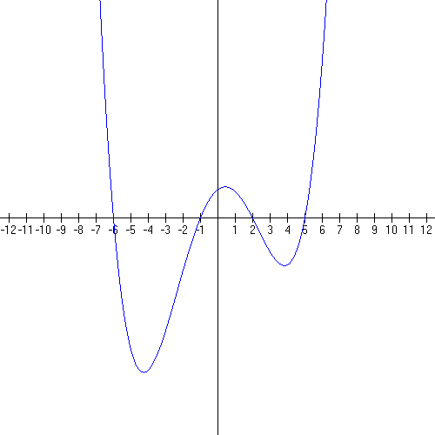
This is the graph of f(x) = (x + 6)(x + 1)(x − 2)( x − 5). List the domain, the x-intercepts, the y-intercept (intercepts in point coordinate form, please). Label the turn-around points TP1, TP2, TP3. Indicate where the graph is increasing and decreasing.

Domain:

x-intercepts:

y-intercept:

Increasing on:

Decreasing on:

Question 2 15 points (1 point each answer; 5 points for the graph)

Tell me everything about . Graph the function on a separate sheet and show all the important pieces of the graph clearly.

Domain

Range

VA

Holes

HA

Intercepts

How does the graph act around the VA?

How does the graph act around the HA?

Where is the graph increasing?

Where is the graph decreasing?

Put the graph on the next page, please

Graph.

Label the graph FULLY and CAREFULLY

3. 24 points (8 each)

Compute at least 5 more terms of the following sequences. (3 pt)
Discuss bounds…lub and glb. (4 pt)
Graph at least 5 point pairs very clearly and in two dimensions: (n, term n) (3 pt)

3a. n is a natural number

3b. the Fibonnacci sequence – the “f” is the special name for each term in this sequence…there’s a BUNCH of stuff on the internet about it

3c. n is a natural number

…

3d.

4. Arithmetic sequences – show your work in agonizing detail.
12 points (4 points each part)

a. Given the following sequence find the 100th term:
6, 11, 16, 21, …

b. The 60th term of an arithmetic sequence is 105 and the common difference between terms is 5. Find the first term.

c. The 5th term of an arithmetic sequence is ½ and the 20th term is 7/8.
Specify the sequence in terms of a and d.

5. Find the 8th term of the following geometric sequences. Are the sequences bounded above, below, both, or neither? Discuss upper and lower bounds.

10 points total; 5 points each part

A. 1, , 2, , …

B. 2/3, 4/9, 8/27, …

Question 6: 12 points (4 points each part)

A. What is the likely formula for this graph?

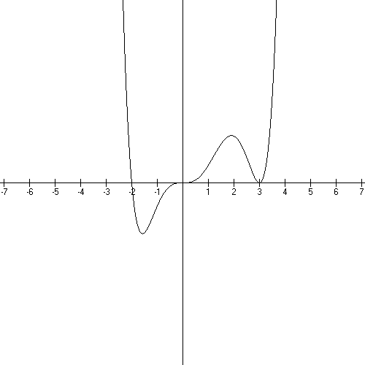

B. What is the likely formula for this graph?

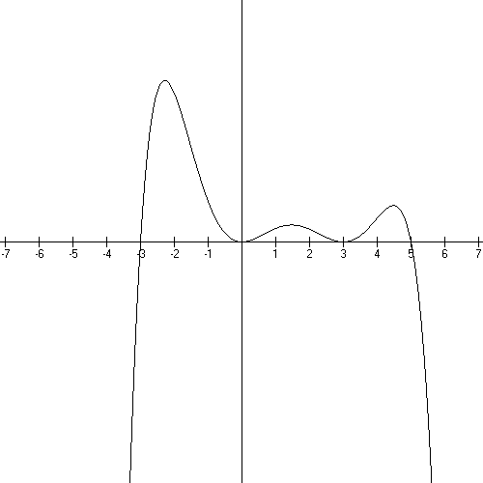

C. What is the likely formula for this graph?

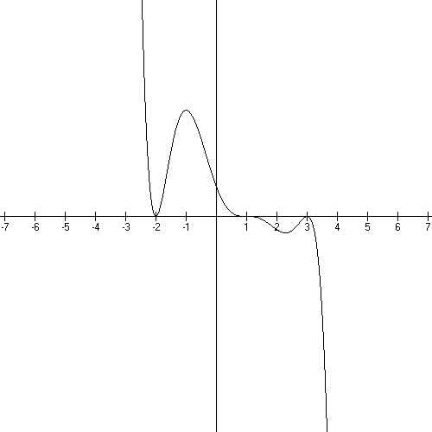

Question 7 20 points (5 points each part)

7A. Sketch the graph of $f(x)=−x^{2}(x−1)^{2}(x+5)$

The leading term is:
(1 point)

The constant term is:
(1 point)

Sketch: (3 points)

7B. Sketch the graph of $f(x)=−(x+3)(x−2)$.

The leading term is

The constant term is

Sketch:

7C. Sketch the graph of $f(x)=(x+3)^{2}(x−2)^{2}$

The leading term is:

The constant term is:

Sketch:

7D. Sketch the graph: $f(x)=−(x−1)^{3}(x+4)^{2}$.

The leadning term is:

The constant term is:

Sketch:

Question 8 40 points

Graph the following functions -- one per attached page. List the domain, y-intercept, x-intercepts (point coordinates); discuss holes, end behavior; list any asymptotes (equation of the asymptote). Note that Math GV doesn’t put in holes or asymptote lines….you have to supply those yourself.

A.

Domain
(1 point)

Intercepts
(1 point)

End behavior
(1 point)

Asymptotes/holes
(1 point)

Graph
(6 points)

B.

Domain
(1 point)

Intercepts
(1 point)

End behavior
(1 point)

Asymptotes/holes
(1 point)

Graph
(6 points)

C.

Domain
(1 point)

Intercepts
(1 point)

End behavior
(1 point)

Asymptotes/holes
(1 point)

Graph
(6 points)

D.

Domain
(1 point)

Intercepts
(1 point)

End behavior
(1 point)

Asymptotes/holes
(1 point)

Graph
(6 points)

